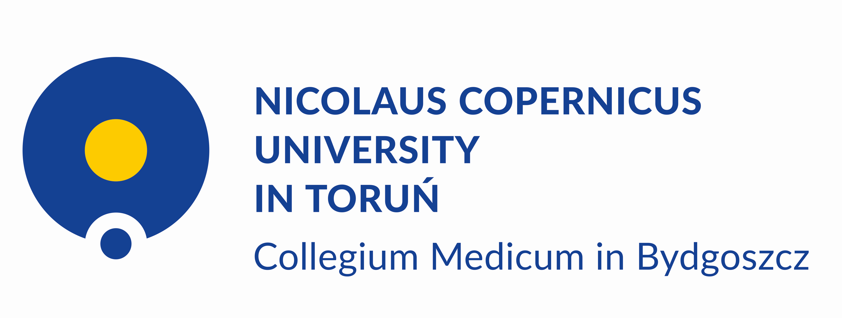

Faculty of Medicine

program: Medicine

**John Smith**

group I



Faculty of Health Sciences

program: Physiotherapy

**John Smith**

group I